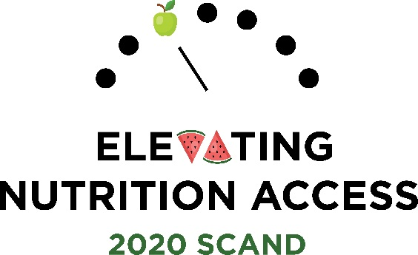
South Carolina Academy of Nutrition and Dietetics
Annual Meeting – April 3, 2020
Brookland Banquet and Conference Center
1066 Sunset Blvd. | West Columbia, SC 29169

DIRECTIONS:

- Complete and submit a form for each abstract submission.
- Refer to “SCAND 2020 Call for Abstracts for Poster Presentations” for abstract submission guidelines and follow the directions carefully

- Email your completed form (saved as word document- see submission guidelines) with your abstract (saved as a word document- see submission guidelines) by: February 28, 2020 to: eatrightsc@capconsc.com

- If your abstract is accepted, you must attend the SCAND Annual Meeting and be present throughout the poster session

ABSTRACT SUBMISSION FORM- TO BE COMPLETED BY PRESENTER/CORRESPONDING AUTHOR
First Name, Middle Initial, Last Name and Credentials (EXACTLY as you wish it to be printed)
Street Address |  |  |  |  |  |  | Apartment/Unit #
City |  |  |  | State |  |  | ZIP
Phone (include area code) |  |  |  | E-mail Address
Fax
IF YOU ARE A STUDENT- PLEASE COMPLETE THE FOLLOWING
Name of College or University You Attend
Program Concentration
Student Status (check box)  Graduate □ Undergraduate □ |  | If Undergraduate- check year in program  Freshman □ Sophomore □ Junior □ Senior □
University or College Address
Full Name and Credentials of Faculty Advisor or Faculty Mentor
Email Address of Advisor/Mentor
Daytime Phone of Advisor/Mentor

SCAND, PO Box 1763, Columbia, S.C. 29202 | (803) 255-7223 | eatrigtsc@capconsc.com

